**Sameer Khan  
Batch: MIP-DA-04**

**Hotel Reservation Analysis (Source Code)**

**How I imported the provided dataset excel file into MySQL Workbench:**

* Create database in MySQL (hotel_reservation) –
* Right clicking on database –
* Table Data Import Wizard –
* Select excel file and import.
* **What is the total number of reservations in the dataset?**

**SELECT COUNT**(booking_id) **AS** Total_Number_Of_Res **FROM** hotel_reservation  
  
  


**Result**

* **Which meal plan is the most popular among guests?**

**SELECT** type_of_meal_plan, **COUNT**(*) **AS** Most_liked_by_GUESTS

**FROM** hotel_reservation

**GROUP BY** type_of_meal_plan;  
  
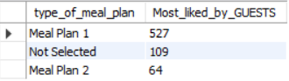

**Result**

This query will show most popular mean plan among the guests, we can show a single by adding LIMIT 1;

* **What is the average price per room for reservations involving children?**

**SELECT** **AVG** (avg_price_per_room)  
**FROM** hotel_reservation  
**WHERE** no_of_children >0; 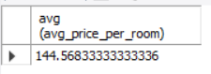

**Result**

* **How many reservations were made for the year 2018 (replaced XX with the 2018)**

**SELECT COUNT**(booking_id) **AS** booking_count_of_2018

**FROM** hotel_reservation

**WHERE YEAR**(arrival_date) = 2018;

**I changed the data type of arrival_date column from TEXT to DATE to get the accurate result.**

**Result**



* **What is the most commonly booked room type?**

**SELECT** room_type_reserved, **COUNT(*) AS** Booking_COUNT  
**FROM** hotel_reservation  
**GROUP BY** room_type_reserved  
**ORDER BY** booking_count **DESC**  
**LIMIT** 1;

**Result**

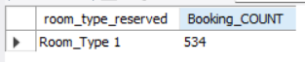

IF you need to see the other room types then you can change the **LIMIT** with 1 – any number or simply remove it to get below result:

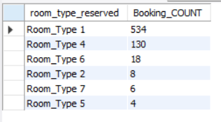

By removing **LIMIT** I got the list of all room types with their booking count in **DESCENDING ORDER.**

**(By Default it’s always in Ascending Order)**

* **How many reservations fall on a weekend (no_of_weekend_nights > 0)?**

**SELECT COUNT(*) AS** weekend_reservations  
**FROM** hotel_reservation  
**WHERE** no_of_weekend_nights > 0;

**Result**

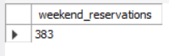

* **What is the highest and lowest lead time for reservations?**

**SELECT**   
**MAX**(lead_time) **AS** highest_lead_time,  
 **MIN**(lead_time) **AS** lowest_lead_time  
**FROM** hotel_reservation;

**Result**



You can always give name a temporary to a column, by using **AS** function

* **What is the most common market segment type for reservations?**

**SELECT** market_segment_type, **COUNT**(*) **AS** Common_Mar_Seg

**FROM** hotel_reservation

**GROUP BY** market_segment_type

**ORDER BY** common_mar_Seg DESC

**LIMIT** 1;

**Result**



IF you need to see the other segment types then you can change the **LIMIT** with 1 – any number or simply remove it.

By removing **LIMIT** I can get the list of all Segment types with their count in **DESCENDING ORDER (By Default it’s always in Ascending Order)**

* **How many reservations have a booking status of "Confirmed"?**

**SELECT COUNT**(booking_status) **AS** Confirmed_Booking

**FROM** hotel_reservation

**WHERE** booking_status = 'Not_Canceled'

**Result**



* **What is the total number of adults and children across all reservations?**

**SELECT**

**SUM**(no_of_adults) AS total_adults,

**SUM**(no_of_children) AS total_children

**FROM**

hotel_reservation;

**Result**



**This query will show the total number of adults & children of all the reservations including canceled. If you want to see only confirmed once then we can add “Where = Booking_status = ‘Confirmed’;”**

* **What is the average number of weekend nights for reservations involving children?**

**SELECT AVG**(no_of_weekend_nights)

**FROM** hotel_reservation

**WHERE** no_of_children > 0;

**Result**



* **How many reservations were made in each month of the year?**

**SELECT**

**MONTH(STR_TO_DATE**(arrival_date, '%d-%m-%Y')) **AS** month_of_reservation,

**COUNT**(*) **AS** reservations_count

**FROM** hotel_reservation

**GROUP BY** month_of_reservation

**ORDER BY** month_of_reservation

**Result**

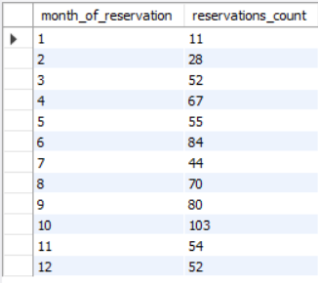

* **What is the average number of nights (both weekend and weekday) spent by guests for each room type?**

**SELECT**

room_type_reserved,

**AVG**(no_of_weekend_nights + no_of_week_nights) **AS** avg_total_nights,

**COUNT**(*) AS reservations_count

**FROM** hotel_reservation

**GROUP BY** room_type_reserved

**ORDER BY** avg_total_nights DESC;

**Result**

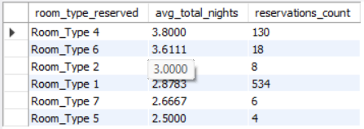

* **For reservations involving children, what is the most common room type, and what is the average price for that room type?**

**SELECT MAX**(room_type_reserved) **AS** most_common_room_type_with_children,

**AVG**(avg_price_per_room) **AS** average_price,

**COUNT**(*) **AS** number_of_reservations

**FROM** hotel_reservation

**WHERE** no_of_children > 0;

**Result**



* **Find the market segment type that generates the highest average price per room**

**SELECT** market_segment_type,

**AVG**(avg_price_per_room) **AS** avg_price_room

**FROM** hotel_reservation

**GROUP BY** Market_segment_type

**ORDER BY** avg_price_room **DESC**;

**Result**

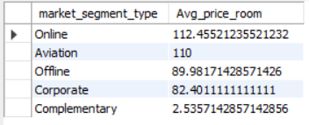

This query will show the **Highest AVG price per room by market segement** in **Descnding order.**

We can always use the **LIMIT** function to show 1 or more than 1 values. Since, the question indicates only segement not segemets so the result will like below.



**  
Bonus TIP:**

Comment out **SELECT * FROM “TABLE_NAME”** with ‘- -’ and keep it on top, whenever you need to peek into data just select the portion and click on execute.in MySQL WorkBench **CTRL+ENTER** is the shortcut to execute the QUERY.

Once, you’re done writing your query just press **CTRL+ENTER** and it will be executed.

These quick tips not only saves time but also keeps you focused on typing rather than clicking around. Get comfortable with your keyboard shortcuts and watch your efficiency soar!"  
 